Music For The Jilted Generation
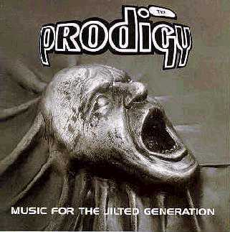

Intro
So, I've decided to take my work underground
To stop it falling into wrong hands
Break & Enter
Break it down to earth
Break it down to earth
Break it down to earth
Their Law
What we re dealing with here is a total lack of respect for the law
Fuck the law but you can't beat the law
Fuck the law but you can't beat the law
Fuck the law but you can't beat the law
Fuck 'em and their law
Crack down at sundown
Fuck 'em and their law
Full Throttle
(Instrumental)
Voodoo People
Magic people, voodoo people
Voodoo
The voodoo, who-do-what-you-don't-dare-to-people
The voodoo, who-do-what-you-don't-dare-to-people
The voodoo
The voodoo, who-do-what-you-don't-dare-to-people
The voodoo, who-do-what-you-don't-dare-to-people
Voodoo people, magic people, voodoo people, magic people
Speedway (Theme from Fastlane)
(Instrumental)
The Heat (The Energy)
Can you feel it?
The energy, the heat
The energy, the heat
Poison
Liam, someone on the phone for you
Oh, fuck's sake, tryin' to write this fucking tune, man
Yeah, yeah, yeah
(In the background: Boom, bah!)
(Also in the background: Hit the ground)
I got the poison, I got the poison
I got the poison, I got the poison
I got the poison, I got the remedy
I got the pulsating rhytmical remedy
I got the poison, I got the remedy
I got the pulsating rhytmical remedy
I got the poison, I got the remedy
I got the pulsating rhytmical remedy
I got the poison, I got the remedy
I got the pressure, the pressure
I got the poison, I got the remedy
I got the pulsating rhytmical remedy
I got the poison, I got the remedy
I got the pulsating rhytmical remedy
I got the poison, I got the remedy
I got the pulsating rhytmical remedy
I got the poison, I got the remedy
I got the pulsating rhytmical remedy
No Good (Start The Dance)
You're no good for me
I don't need nobody
Don't need no-one
That's no good for me
You're no good for me
I don't need nobody
Don't need no-one
That's no good for me
You're no good for me
I don't need nobody
Don't need no-one
That's no good for me
One Love (Edit)
One love, one love
One love, one love
One love, one love
Claustrophobic Sting
My mind is glowing
My mind is glowing
My mind is glowing

